EXPERIMENT 16
SIMULATION AND ANALYSIS OF UNIFORM AND NON-UNIFORM QUANTIZATION USING MATLAB

clc; clear; close all;
% Input Signal t = 0:0.001:1;
x = sin(2pi5t); % Uniform Quantization (8 Levels) L = 8; x_uni = round((x+1)(L-1)/2);
x_uni = (x_uni2/(L-1))-1;
% Non-Uniform Quantization (μ-law) mu = 255; x_comp = sign(x).log(1+muabs(x))/log(1+mu); x_non = round((x_comp+1)(L-1)/2);
x_non = (x_non*2/(L-1))-1;
% Plot Results figure; subplot(3,1,1) plot(t,x) ; title('Original Signal') ; grid on ;
subplot(3,1,2) ; stairs(t,x_uni) ;
title('Uniform Quantization') ;

grid on ; subplot(3,1,3) ; stairs(t,x_non) ;
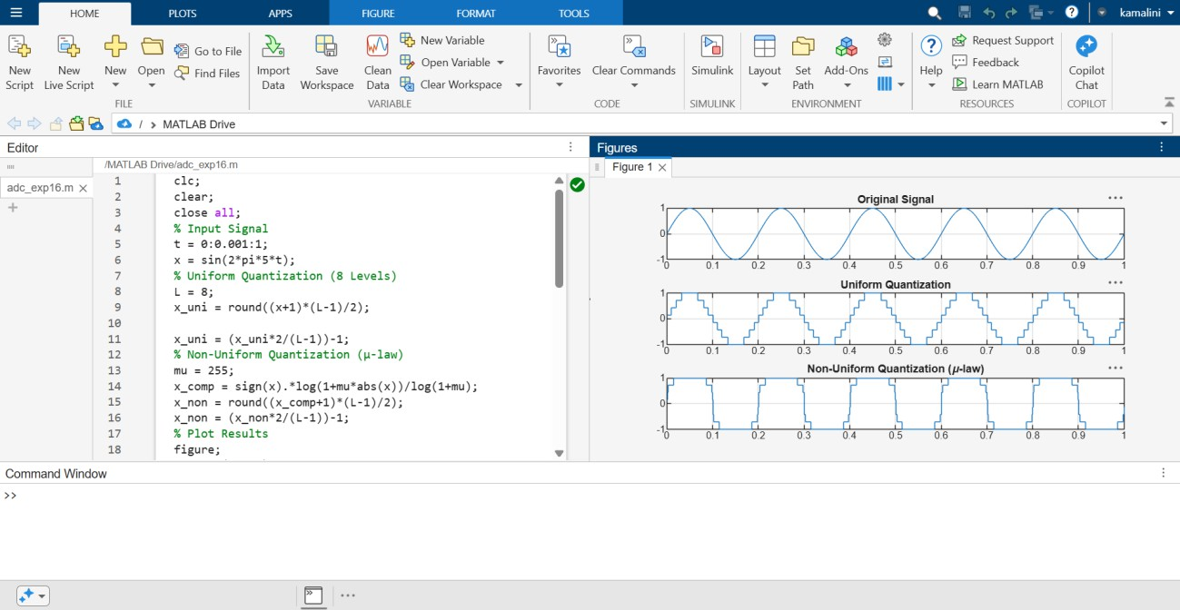
title('Non-Uniform Quantization (\mu-law)') ; grid on ;

